

Software Architectural & Design

**Version1.0**

**<Quang Vuong>**

**<5/12/2019>**

**VERSION HISTORY**

|  |  |  |  |  |  |
| --- | --- | --- | --- | --- | --- |
| **Version #** | **Implemented**  **By** | **Revision**  **Date** | **Approved**  **By** | **Approval**  **Date** | **Reason** |
| 1.0 | Quang Vuong | 5/12/2019 |  |  |  |
| 1.1 | Quang Vuong | 7/12/2019 | Team | 7/12/2019 | Team approve and update |
|  |  |  |  |  |  |
|  |  |  |  |  |  |

Content

1 Introduction 4

1.1 About this document 4

1.2 Definitions and Acronyms 4

2 Architectural Documentation 4

2.1 Context Diagram 4

2.2 Performance 5

2.2.1 Decomposition Rationale 5

2.2.2 Element Responsibilities Catalog 5

2.2.3 Relationship Responsibilities Catalog 6

2.3 Portability 7

2.3.1 Decomposition Rationale 7

2.3.2 Element Responsibilities Catalog 7

2.3.3 Relationship Responsibilities Catalog 8

2.4 Portability 9

2.4.1 Decomposition Rationale 9

2.4.2 Element Responsibilities Catalog 9

2.4.3 Relationship Responsibilities Catalog 10

2.5 Usability 11

2.5.1 Decomposition Rationale 11

2.5.2 Element Responsibilities Catalog 11

2.5.3 Relationship Responsibilities Catalog 12

3 Requirements Traceability Matrix 12

# 1 Introduction

## About this document

This document contains the software architecture for the Architecture Studio project. It is advised that the reader familiarize themselves with the Architectural Drivers Specification document first before examining the architecture detailed in this document.

## Definitions and Acronyms

All terms and acronyms used in this document have been defined in the Sandcastle Glossary document. Please refer to that document for further information. If you didn’t get the glossary with this document, please contact a Sandcastle team member.

# Architectural Documentation

## Context Diagram

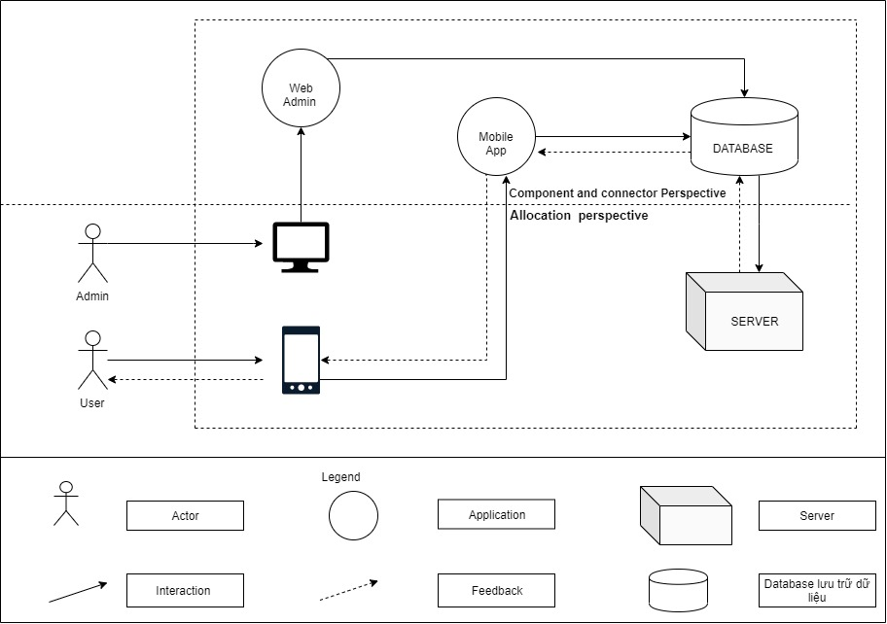

Figure 1 Context Diagram

## Performance

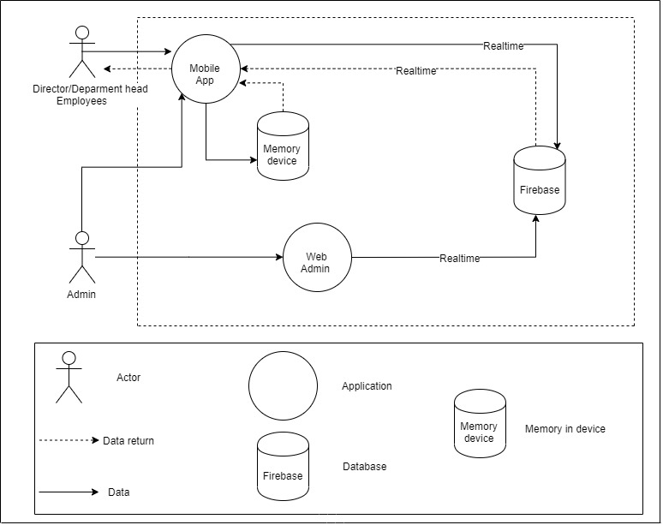

Figure 2 Performance

### Decomposition Rationale

|  |  |
| --- | --- |
| **Associated Drawings:** Figure 2  **Associated Responsibilities:** Catalog 1, Catalog 2 | **Perspective:** Dynamic |
| This diagram shows users can use app the same database with real time database help query, retrieve data fastest | |

### Element Responsibilities Catalog

**Catalog 1 Elements - Dynamic**

|  |  |
| --- | --- |
| **Associated Drawings:** Figure 2 | **Perspective:** Dynamic |
| **Element** | **Responsibilities** |
| Database | Where data is stored |
| Memory in device | Cache memory of smartphone |
| Actor | User use app BDS anh web admin |
| Application | App BDS and web admin |
| Data | Data transmitted to database |
| Data return | Data from database return to device of users |

### Relationship Responsibilities Catalog

**Catalog 2 Relationships**

|  |  |
| --- | --- |
| **Associated Drawings:** Figure 2 | **Perspective:** Dynamic, physical |
| **Relationship** | **Responsibilities** |
| Data | Data transmitted from device users to database |
| Data return | Data from database return to device of users |

## Portability

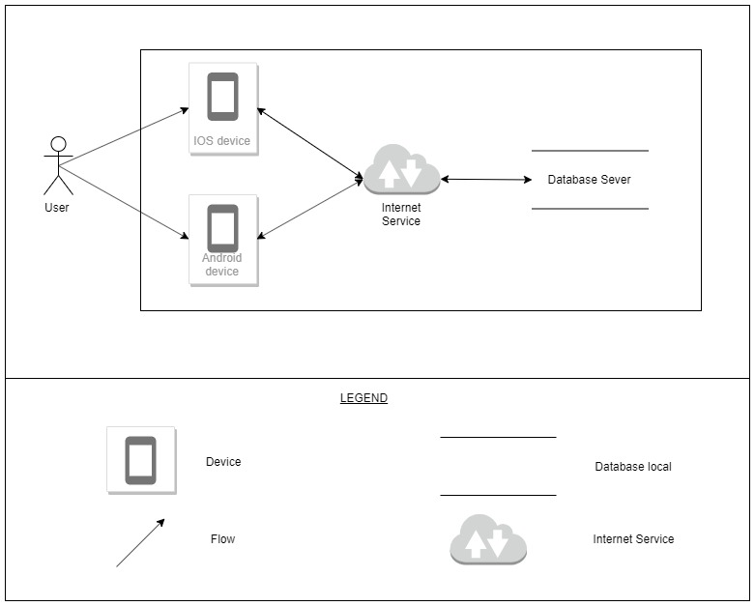

Figure 3 Portability

### Decomposition Rationale

|  |  |
| --- | --- |
| **Associated Drawings:** Figure 2  **Associated Responsibilities:** Catalog 1, Catalog 2 | **Perspective:** Physical |
| This diagram shows one user can use on two foundation, 2 Foundation uses the same database | |

### Element Responsibilities Catalog

**Catalog 1 Elements – Phisycal**

|  |  |
| --- | --- |
| **Associated Drawings:** Figure 2 | **Perspective:** Physical |
| **Element** | **Responsibilities** |
| Database Sever | Where data is stored |
| IOS device | It is device |
| Android device | It is device |

### Relationship Responsibilities Catalog

**Catalog 2 Relationships**

|  |  |
| --- | --- |
| **Associated Drawings:** Figure 2 | **Perspective:** Dynamic |
| **Relationship** | **Responsibilities** |
| Data | This relationship will be used to connect the elements together. This symbol indicates an asset A will transfer the data to the B element. Element B will receive information data |
| Data flow | This relationship will be used to connect the elements together. This symbol indicates an asset A will transfer the data to the B element. Element B will receive information about the data and returns |

## Portability

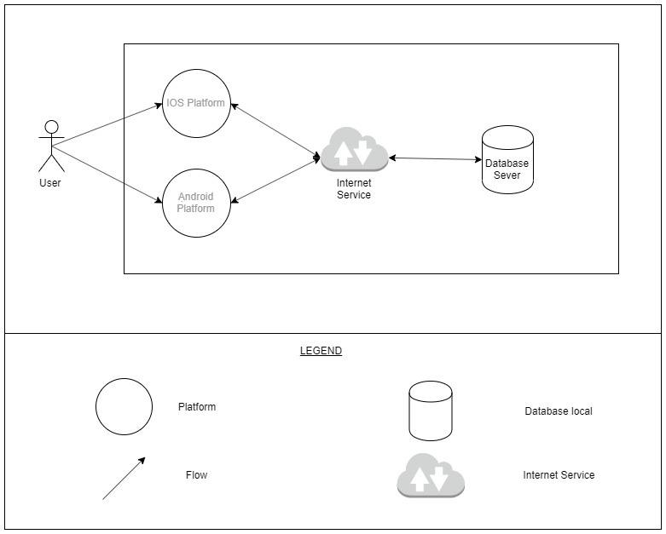

Figure 3 Portability

### Decomposition Rationale

|  |  |
| --- | --- |
| **Associated Drawings:** Figure 3  **Associated Responsibilities:** Catalog 1, Catalog 2 | **Perspective:** Dynamic |
| This diagram shows one user can use on two foundation, 2 Foundation uses the same database | |

### Element Responsibilities Catalog

**Catalog 1 Elements – Phisycal**

|  |  |
| --- | --- |
| **Associated Drawings:** Figure 2 | **Perspective:** Dynamic |
| **Element** | **Responsibilities** |
| Database Sever | Where data is stored |
| IOS Platform | It is Platform |
| Android Platform | It is Platform |

### Relationship Responsibilities Catalog

**Catalog 2 Relationships**

|  |  |
| --- | --- |
| **Associated Drawings:** Figure 2 | **Perspective:** Dynamic |
| **Relationship** | **Responsibilities** |
| Flow | This relationship will be used to connect the elements together. This symbol indicates an asset A will transfer the data to the B element. Element B will receive information data |
| Data flow | This relationship will be used to connect the elements together. This symbol indicates an asset A will transfer the data to the B element. Element B will receive information about the data and returns |
|  | Connection between two devices |

## Usability

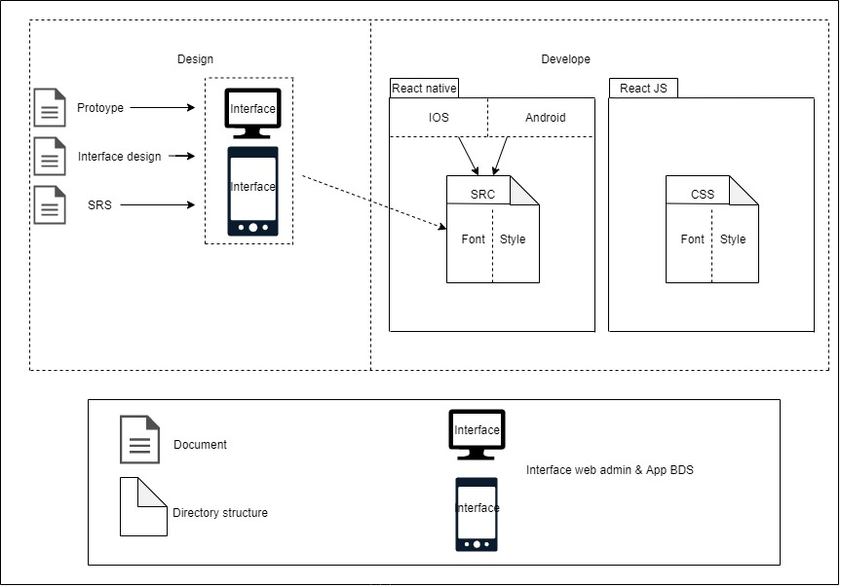

Figure 4 Usability

### Decomposition Rationale

|  |  |
| --- | --- |
| **Associated Drawings:** Figure 4  **Associated Responsibilities:** Catalog 1, Catalog 2 | **Perspective:** Static |
| This diagram shows how to design app interface for users to easily use | |

### Element Responsibilities Catalog

Catalog 1 Elements – Static

|  |  |
| --- | --- |
| **Associated Drawings:** Figure 4 | **Perspective:** Static |
| **Element** | **Responsibilities** |
| Document | contains the design |
| Directory structure | Directory structure of phase develope |
| Interface web admin & app BDS | Interface web & app in phase design |

### Relationship Responsibilities Catalog

**Catalog 2 Relationships**

|  |  |
| --- | --- |
| **Associated Drawings:** Figure 4 | **Perspective:** Static |
| **Relationship** | **Responsibilities** |
|  | B include A |

# Requirements Traceability Matrix